

User Guide

Version 1.0 — April 2018

Contents
1. Welcome | 2
1.1 Tips for Parents | 3
1.2 Getting Familiar with FamilyMode | 4
2. Getting Started | 6
2.1 Setting up FamilyMode | 6
2.2 Adding Kid Devices | 7
3. Using FamilyMode | 9
3.1 The Home Screen | 9
3.2 Pause | 11
3.3 Profiles | 12
3.4 Location | 13
3.5 Devices | 14
3.6 History | 15
3.7 Usage | 16
3.8 Filter | 17
3.9 BedTime | 20
3.10 Time Limits | 21
3.11 OffTime | 22
3.12 Rewards | 23
3.13 Dashboard | 24
4. Home Base | 25
4.1 Setting up a Home Base | 26
4.2 Wi-Fi Devices & Home Base | 27
4.2 Troubleshooting | 28
5. Legal | 29

1. Welcome

What is FamilyMode?
FamilyMode is a set of software applications and services that lets families manage content and time online for all of their iOS and Android devices. FamilyMode gives each of your family members a consistent experience across all their devices that matches their age and interests. Parents set limits from the FamilyMode mobile app using their Primary Account Holder T-Mobile ID, while kids or other family members can keep track of their own time online with the Dashboard.
By using FamilyMode on your family’s devices, you can control which websites and apps each managed device has access to, as well as the times of day when the Internet is available. FamilyMode uses a local Virtual Private Network (VPN) to help secureall Internet data coming and going from each device.

Introducing FamilyMode Home Base
A Home Base extends your mobile experience with FamilyMode to your entire Wi-Fi network, allowing you to manage every connected device in your home — laptops, smart TVs, game consoles, and everything else. You’ll still use the FamilyMode app, but you’ll have the added functionality of Home Base built right in.

1.1 Tips for Parents
The Family Online Safety Institute is an international nonprofit organization which works to make the online world safer for kids and their families through research, resources, events, and special projects. T-Mobile is a member of FOSI and recommends that families look to FOSI when thinking about digital health. Learn more at fosi.org/good-digital-parenting/

Setting your family up for success with FamilyMode
Managing Internet use is a balancing act with no single “right” answer. With that in mind, we made FamilyMode as flexible as possible, so families can achieve their goals, and roll with the changes that life brings. Setting up FamilyMode for the first time makes for a good occasion to talk with your family about the Internet as a tool which has the potential for both healthy and unhealthy outcomes.
FamilyMode has been designed to foster conversation and transparency between parents and kids. So, by talking with your family, rather than secretly managing them, you’ll be able to set up FamilyMode in a way that everyone respects, and you’ll get the most out of the tools that FamilyMode offers.
As with any parenting tool, FamilyMode doesn’t replace your responsibility as a parent, and it certainly won’t filter out every rude comment or undesirable piece of content that’s shared online. So, it’s helpful for parents to establish family standards that start in person and extend to the Internet — then, use FamilyMode to keep everybody accountable to these agreements. Establishing a family contract can help frame your use of FamilyMode and build a level of trust regarding family Internet management. For more on family contracts, see the links below:
- FOSI: “Establishing a Family Safety Contract” fosi.org/good-digital-parenting/establishing-family-online-safety-contract/
- Growing Wireless: “Family Rules Template” growingwireless.com/learn-engage/tips-for-safe-kids/family-rules-template

1.2 Getting Familiar with FamilyMode
As you use FamilyMode, you’ll come across words
and phrases that might be new to you. In the context of FamilyMode, here are some helpful definitions:
A device is anything that
has an Internet connection.

- Device: Any Internet-connected equipment, like a smartphone, tablet, or laptop computer; plus smart home appliances (“IoT” devices) like smart TVs and thermostats.
- Kid Device: Any internet-connected device that you manage with the FamilyMode app. A kid device could belong to any family member, not just a kid. Also known as “Managed Device.”
- Profiles: FamilyMode settings are shared across all devices assigned to a family member Profile.
- Manage: Network traffic is controlled based on a set of rules that a parent sets up with FamilyMode.
- Unmanage: Internet traffic is allowed to freely come and go from this device or site, even if FamilyMode is set on Pause, BedTime, or OffTime.
- Allowed (Filter setting): Content from this source is available and tracked by FamilyMode as it comes and goes.
- Not Allowed (Filter setting): Content from this source is restricted by the Filter..
- Pause: The Internet is shut off for as long as FamilyMode is Paused. Unmanaged devices and sites can still get through, as always.
Routers often have blinking lights
and are connected to a modem.

- Unpause: Resuming Internet access after being Paused.
- Network: A Wi-Fi, Ethernet, or cellular data source that is used to access the Internet.
- Router: The device that distributes Internet to multiple devices, usually over Wi-Fi.
Platforms are popular apps and services
like Spotify, Instagram, & Netflix.

- Site: An individual source of online content.
- Category: A collection of sites and Platforms that share a common purpose.
- Platform: A popular service, usually made up of several sites and mobile apps.

FamilyMode Features:
- Location: Use FamilyMode to keep track of your family’s locations.
- Rewards: Extra online time that doesn’t affect a Profile’s permanent settings, so you can send a Reward right when a family member deserves one.
- Usage: Compare time online today, last week, or months past.
- Filter: Match each family member’s age and interests with online content that’s right for them.
- BedTime: Make late-night surfing a thing of the past. FamilyMode will Pause each family member’s devices based on sleep and wake times that you set.
- Time Limits: Limit online time for individual apps, sites, categories, and even total time.
- OffTime: Scheduled offline moments that automate a weekly digital Pause.
- History: A detailed breakdown of what sites were visited throughout the day.

2. Getting Started

2.1 Setting Up FamilyMode

Get the T-Mobile FamilyMode app
- On Apple iOS, FamilyMode runs on version 9.3 or newer.
- On Android, FamilyMode runs on version 4.4 (KitKat) or newer.
To find the app, search “T-Mobile FamilyMode” on the Apple App Store (for iOS) or Google Play Store (for Android).

FamilyMode Subscription
You’ll need to be the Primary Account Holder with a qualifying T-Mobile plan with FamilyMode service. To check your eligibility, go to https://my.t-mobile.com.

Setting up FamilyMode for the first time
- Open the app and press “Get Started.”
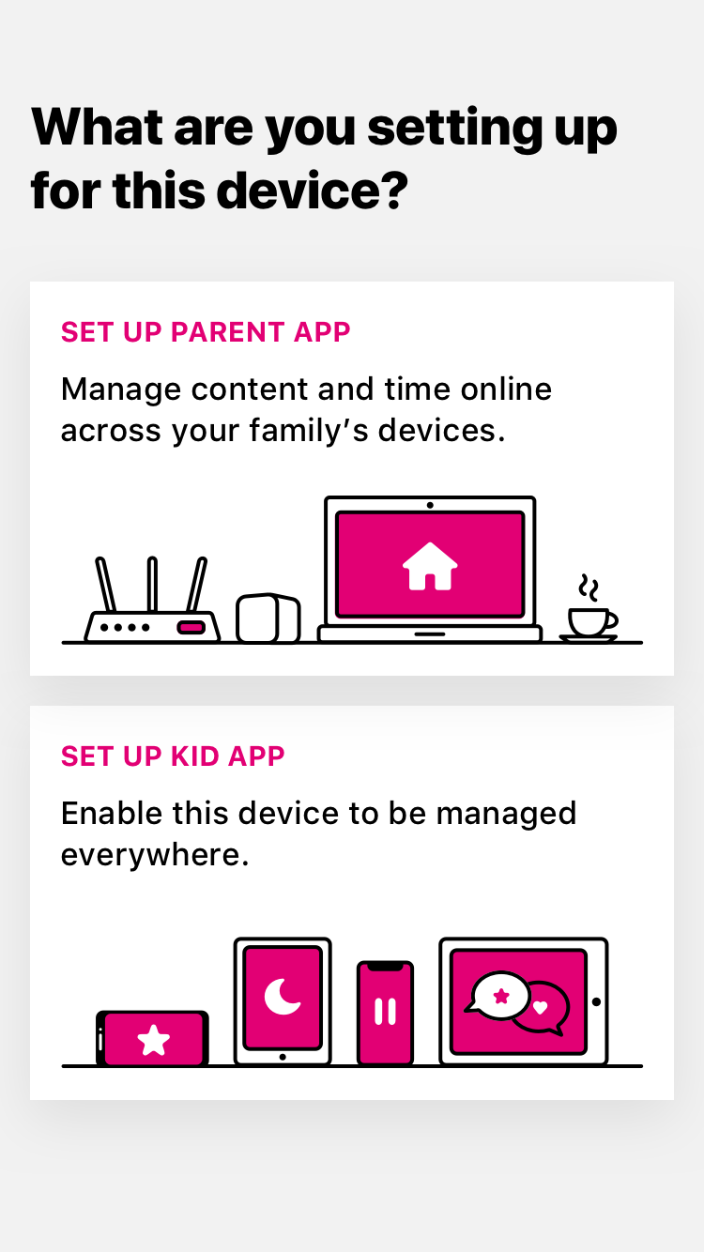
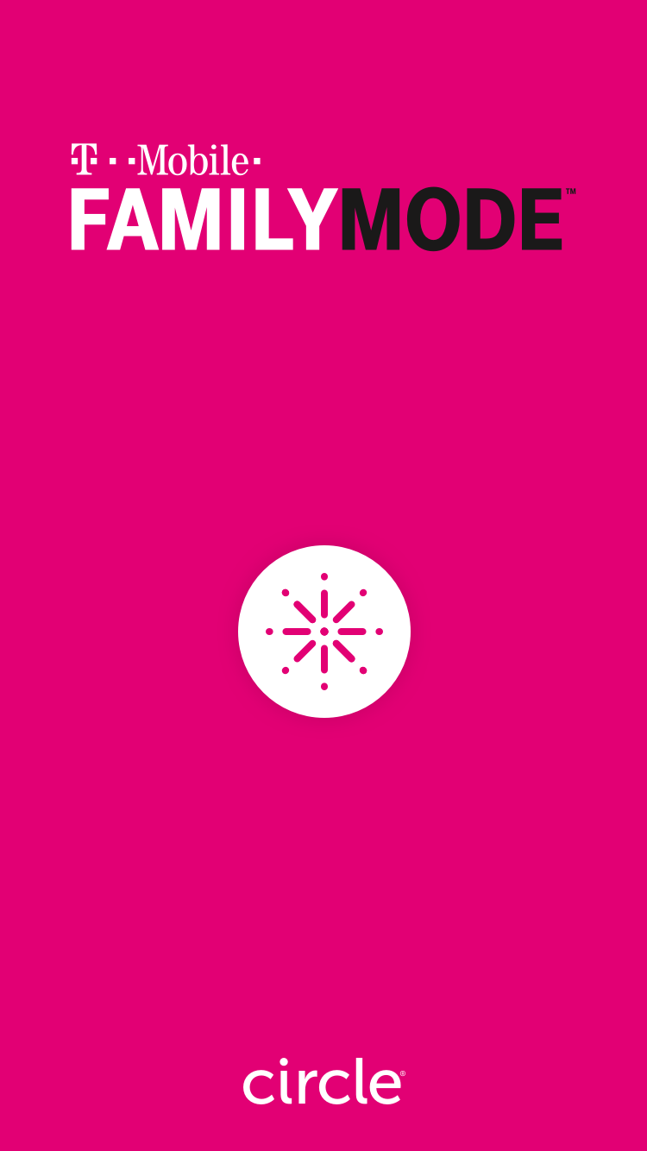
- Agree to the “User Agreement.”
- Select “Set up parent app.”
- Log in using your T-Mobile ID.
To create Profiles for each member of your family:
- Start by typing in a family member’s name and add a photo.
- Set a Filter, Time Limit, or BedTime for their Profile.
- If you have your family member’s mobile device in your hand (iOS or Android), then press “Continue.” If not, tap “Skip” in the upper-right corner.
- After adding devices, tap “Add Another” or “Finish,” if you’re done creating family member Profiles.

2.2 Adding Kid Devices
Managing your family’s mobile devices is as easy as downloading the FamilyMode app and walking through a guided setup process. Make sure you have both your own device (with FamilyMode “parent” access) and any devices you want to manage on-hand, so you can scan kid devices with the parent device.

On the device you want to manage:
- Download the FamilyMode app by searching “T-Mobile FamilyMode” on the Apple App Store (for iOS) or Google Play Store (for Android). FamilyMode runs on iOS 9.3 or newer and Android 4.4 or newer.
- Open the app, tap “Get Started,” and select “Set up kid app.”
- Follow the instructions until you see a large, black QR code displayed on the screen.

Then, on your own device (using the parent app):
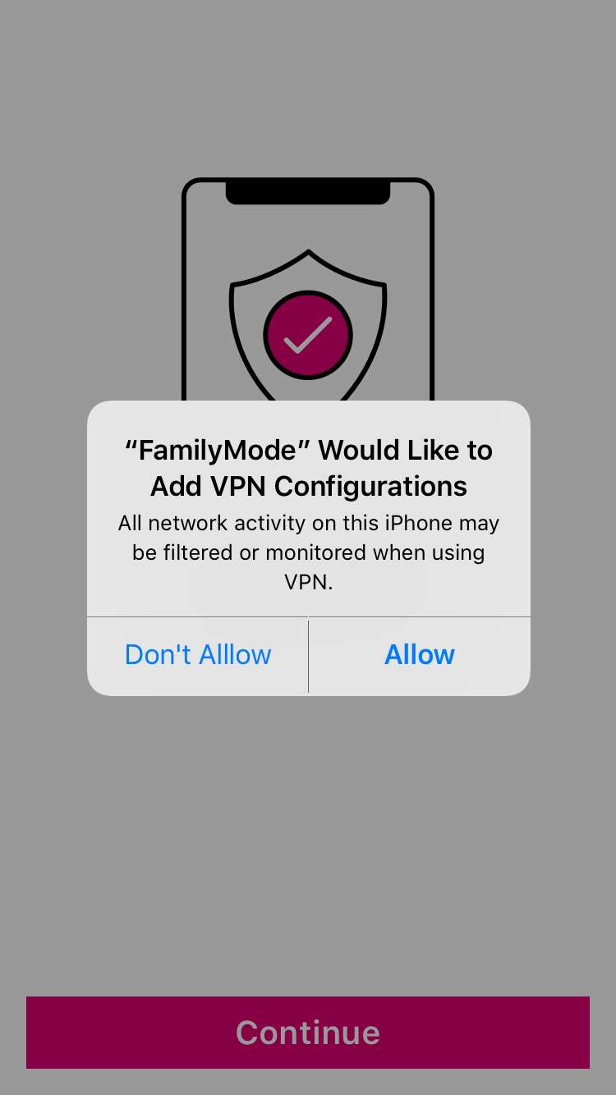
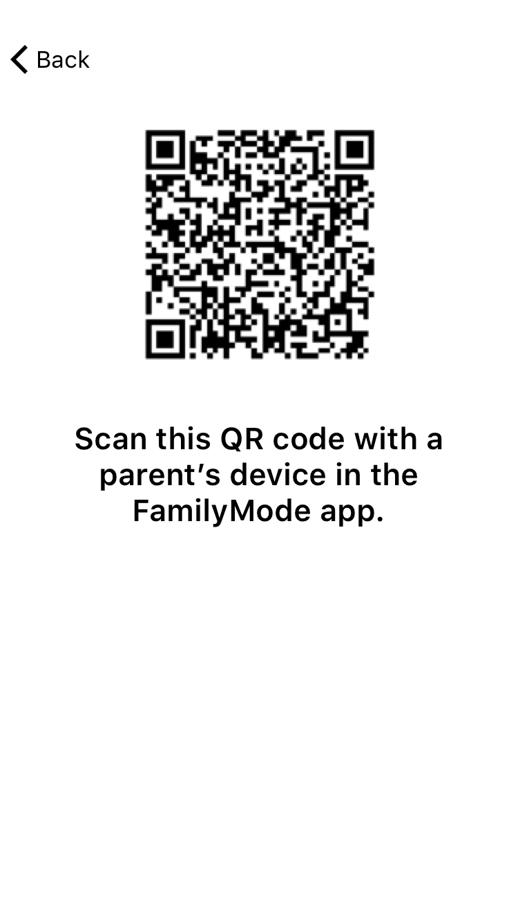
- Make sure you’ve selected the right family member Profile for the device you’re adding.
- Press “Add Device,” or, if you’ve completed setup already, open their Profile, select “Devices” from the feature list, then tap “Add Mobile Device.”
- Use your camera to scan the QR code on the kid app device.
- After a successful scan, you’ll see the device list for this Profile.

To set up the VPN on an Apple iOS device:
- Tap “Continue,” then “Allow” on the alert that says “FamilyMode would like to add VPN configurations.”
- Then, in the iOS Settings app, make sure you approve all changes in order for FamilyMode to be able to manage this device.
- Go back to the FamilyMode app and press “Allow” on the alert boxes if you’d like to enable Location and Push Notifications.
- Give the device back to its owner, and explain what settings you’ve applied to their Profile. This way, they know what to expect and can come to you if they have any issues.

To set up the VPN on an Android device:
- Tap “OK,” then “Activate this device admin app,” then “OK” when you see the “Connection request” alert.
- Press “Allow” on the alert boxes if you’d like to enable Location and Push Notifications for this device.
- Give the device back to its owner, and explain what settings you’ve applied to their Profile. This way, they know what to expect and can come to you if they have any issues.

3. Using FamilyMode

3.1 The Home Screen
When you’ve completed setup, you’ll see the home screen. From here, you can access the home menu (top left), view your device list (top right), tap into a family Profile (center), or Pause the Internet (bottom).

Menu
Tapping the menu button in the top left corner of the screen brings up the home screen menu. Here, you’ll find a selection of handy tools and information.
“Home” takes you back to the home screen.
“Add Profile” lets you create a new Profile for a family member.
“Devices” shows you every device that’s been added to FamilyMode.
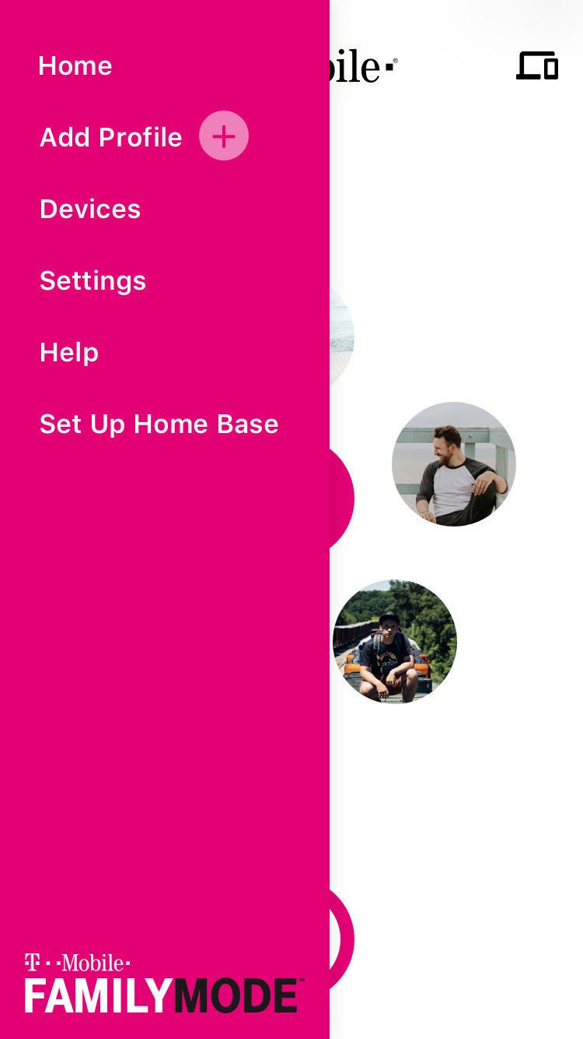
“Settings” allows you to do the following:
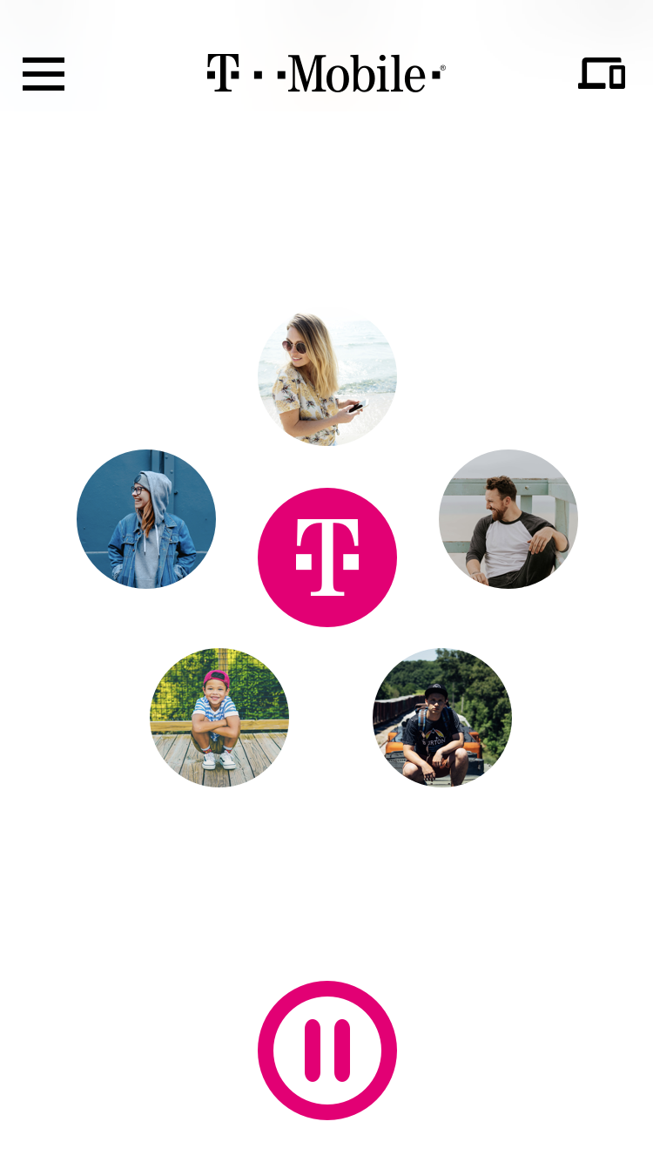
- Check your T-Mobile ID login or tap “Sign Out” to remove your T-Mobile ID from the FamilyMode app on this device.
- Toggle Push Notifications, which include messages for when a family member reaches a Time Limit, a new device joins FamilyMode, a new device is managing FamilyMode, Home Base has gone offline, has a low battery, has been reset, or other issues.
- Set a PIN (to help keep your FamilyMode app secure), by tapping “Lock PIN.” If you forget your PIN and get locked out of FamilyMode, the only way to restore access is to uninstall and reinstall the FamilyMode app, then log in with your T-Mobile ID.
- Reference legal documentation.
- If you’ve set up a Home Base, you can check the firmware version, adjust Wi-Fi settings, view Wi-Fi signal strength, as well as temporarily disable, reboot, and even remove your Home Base from FamilyMode.
“Help” shows you how you can contact T-Mobile support for help with FamilyMode.
“Set Up Home Base” gets you started with a FamilyMode Home Base. To find out more about setting up a Home Base, skip to chapter four: “Home Base."

3.2 Pause
Pause the Internet® at the push of a button, so your family can enjoy some offline time. When you tap Pause, the Internet is shut off. Tapping the Pause button again resumes Internet access. During a Pause, Unmanaged devices and sites can still get through, as always.

Home Pause
To Pause all FamilyMode devices at once, press the Pause button on the home screen, then confirm. Press the same button again to Unpause.

Profile Pause
To Pause a family member, tap on their Profile from the home screen, then tap the Pause button in the top-left corner of the screen. Press the same button again to Unpause.

Device Pause
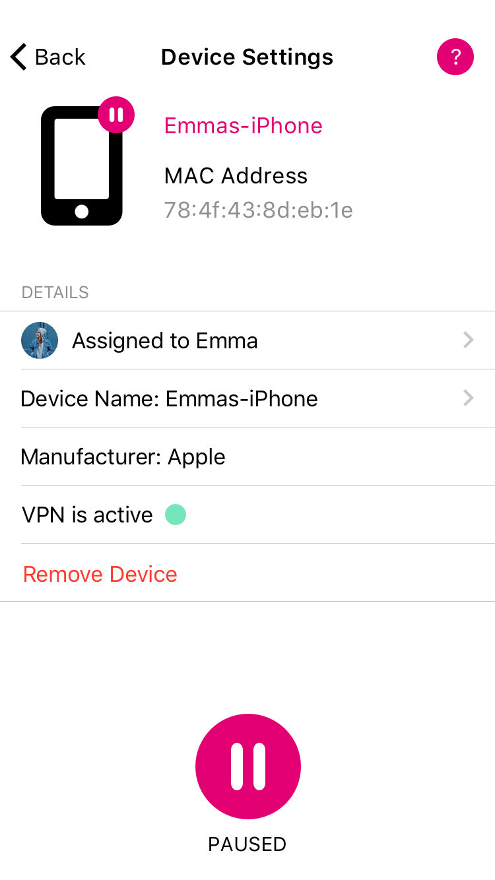
To Pause a single device, tap the Devices icon in the top-right of the home screen, then tap on a device from the list, then press the Pause button on the bottom of the screen. Press the same button again to Unpause.

3.3 Profiles
Create Profiles for every family member, so their FamilyMode settings are shared across all their devices. A Profile is a set of controls for online time and content that are shared across all assigned devices.

To create a new Profile:
- Tap on the Menu button in the top left corner of the screen, then select “Add Profile.”
- Then, type in their name and tap the “Add Photo” button to pick a photo to represent them.
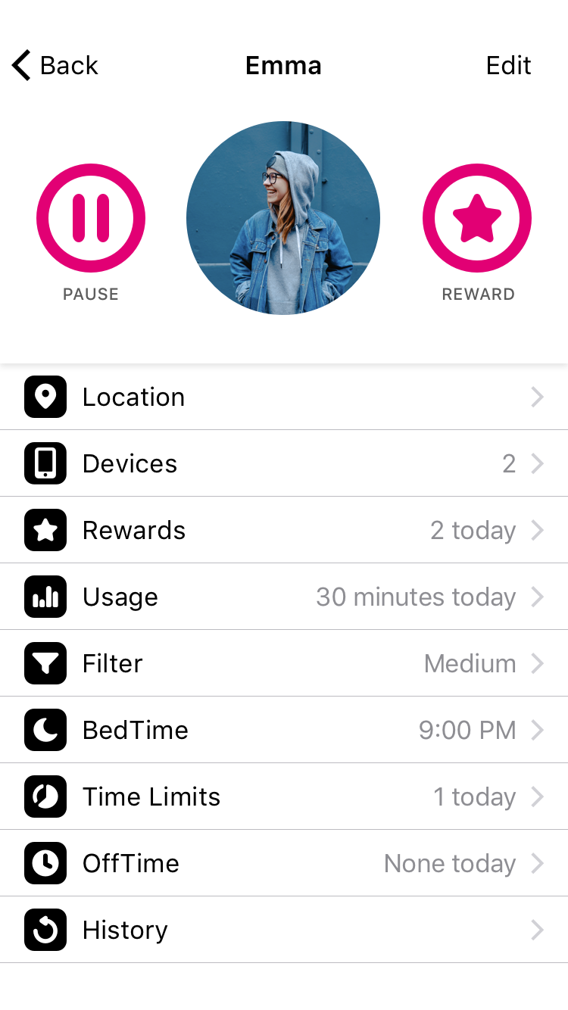
- Follow the steps onscreen to create a few basic settings and assign devices for this family member.

To view a Profile:
- Tap on a Profile from the home screen. From here you can see their name, photo, and FamilyMode settings.
- Tap “Edit” in the top right corner of the screen, where you can type to change the name or tap “Edit Photo” to change the picture. You can also delete the Profile from here. When you’re finished, tap “Done” to save changes or “Cancel” to go back without saving your changes.
- To learn about the features listed on the Profile screen, continue to the next page.

3.4 Location
Keep track of your family’s Location with FamilyMode. To use Location, the Profile you want to locate must have a mobile device with the FamilyMode app installed and Location Services turned on (for more on this, read 2.2 Adding Kid Devices).

To locate a family member’s device:
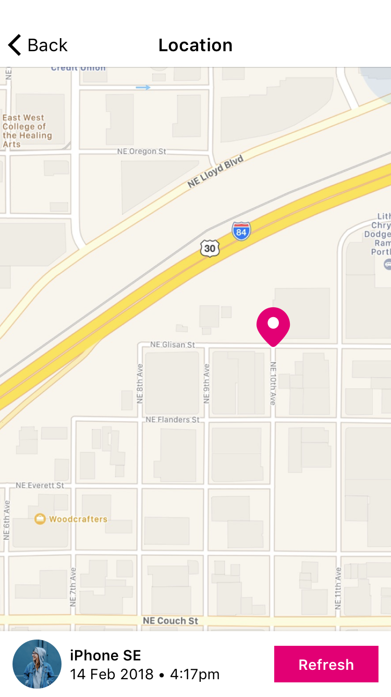
- Tap on a Profile from the home screen, then select “Location” from the feature list. You might have to pick from a list of devices to locate.
- Wait for FamilyMode to locate the device. This can take a minute or two.
- When the device has been found, you’ll see a marker on the map. Use your finger to move around the map, and pinch to zoom.
- At the bottom of the screen, you’ll see the time when the Location was received.
- You can check their device’s Location again by tapping “Refresh.”
- Locating a device will only work if the managed party has Location Services enabled (family members can disable Location Services at any time). FamilyMode will notify you if this is the reason a device cannot be located. We encourage you to refer to 1.1 Tips for Parents for thoughts on discussing FamilyMode settings like Location with children.
- FamilyMode does not store a history of previous locations.

3.5 Devices
A device is any Internet-connected or cellular equipment, like a smartphone, tablet, or laptop computer; plus smart home appliances (“Internet of Things” or “IoT” devices) like smart TVs and thermostats.
From the home screen, you can find a list of all FamilyMode devices by pressing the “Devices” icon in the top-right of the screen.
From a Profile screen, you can find a list of all assigned devices by selecting “Devices” from the features list.
Tap on any device from the Device List to see the Device Settings, where you’ll find:
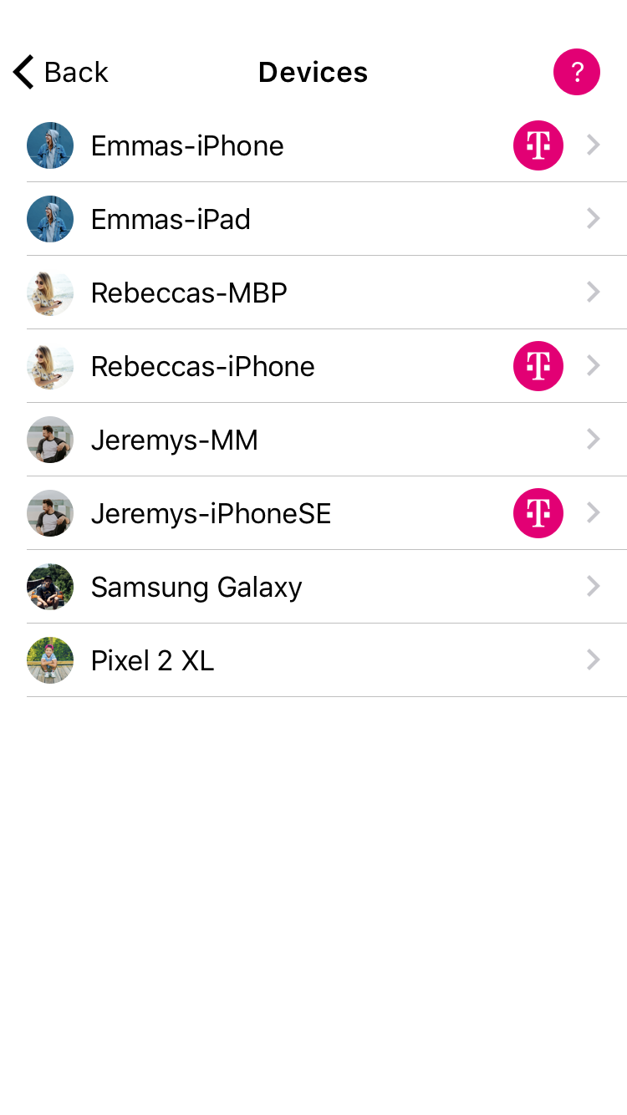
- The assigned Profile (edit by tapping the text).
- The Device Name (edit by tapping the text).
- The Manufacturer and MAC address — which can help you identify the device if you can’t figure out which is which.
- If the device has the FamilyMode app, you’ll see the VPN status.
- The option to “Remove Device,” which deletes this device from FamilyMode. Note: if the device was discovered on your network by Home Base, it will rejoin your Device List as soon as it’s detected again. If you don’t want to manage this device with FamilyMode, set it to Unmanaged.
- A Pause button, just for this single device.

3.6 History
Get a detailed breakdown of what sites were visited throughout the day. The History view is a chronological list of all sites accessed by a Profile’s devices. You can toggle between “Visited” sites and “Filtered” sites to see what this family member viewed and was stopped from viewing by FamilyMode.

To see a family member’s History:
- Tap on a Profile from the home screen, then select “History” in the feature list.
- Select “Visited” to see sites that this family member accessed.
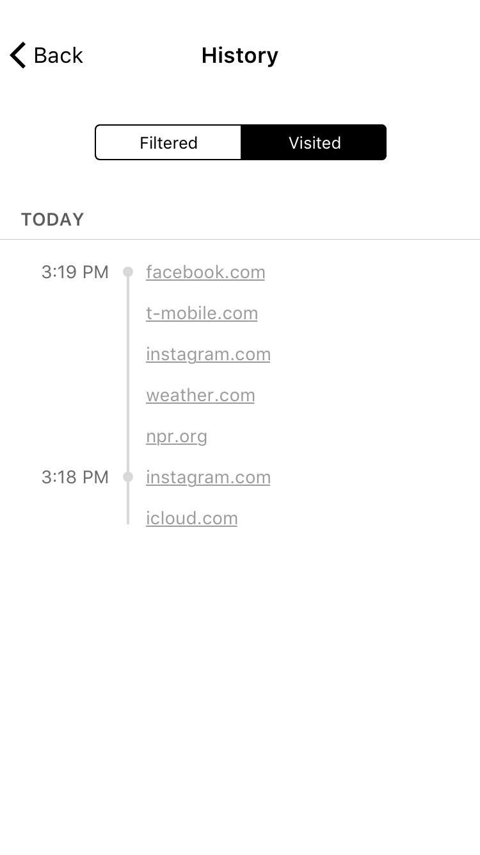
- Toggle over to “Filtered” to see sites that FamilyMode blocked because of this family member’s Filter settings, a Pause state, an expired Time Limit, or an active BedTime or OffTime.

To take action on a History entry, tap on it and select from the following options:
- "Visit Website,” which opens your web browser and takes you to the home page of the site.
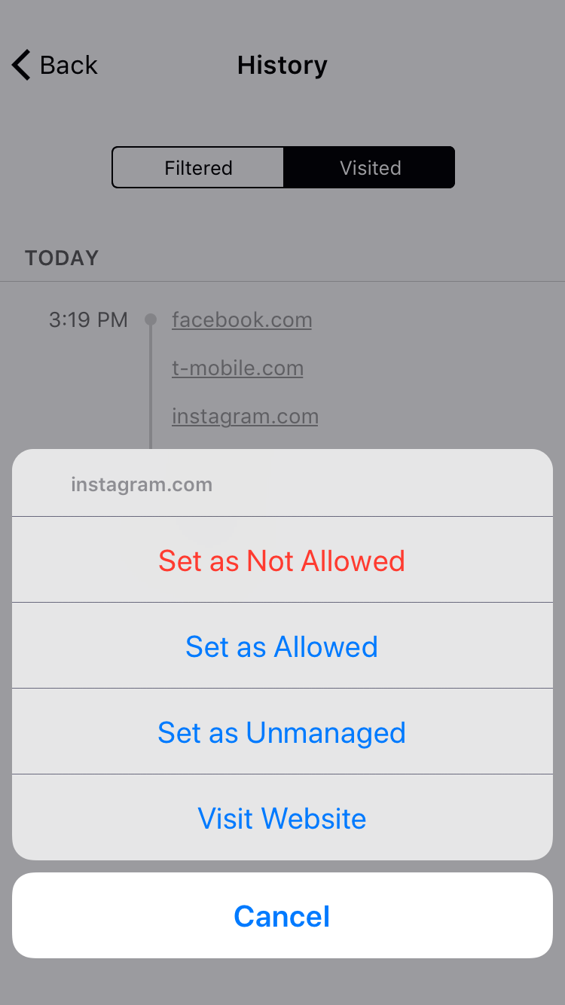
- “Set as Allowed,” which creates a Custom Filter set to “Allowed.”
- “Set as Not Allowed,” which creates a Custom Filter set to “Not Allowed.”
- “Set as Unmanaged,” which creates a Custom Filter set to “Unmanaged.”
You can edit any of these Custom Filters by selecting “Filter" from the Profile features list, then tapping “Custom Filter” on the bottom of the screen.

3.7 Usage
Compare time online today, last week, or months past across all devices assigned to a Profile. Usage adds up time spent online per Category and Platform.
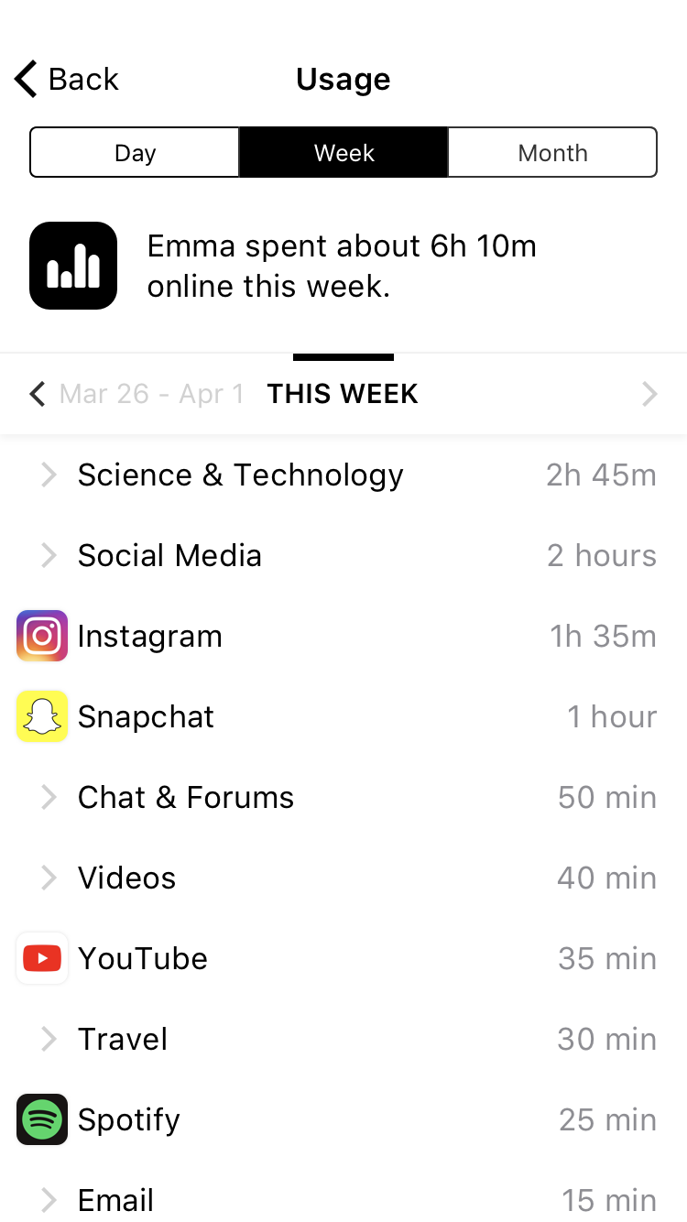
If you tap on a Category, you’ll see a list of sites and Platforms that contributed to the total time for the Category. If you tap on a site or Platform, you can take action on that particular item by using the pop-up menu.

To see a family member’s Usage:
- Tap on a Profile from the home screen, then select “Usage” in the feature list.
- At the top of the screen, you can select whether you’d like to see Usage by the day, week, or month.
- Next, you’ll see a summary of total time.
- Below that, you can scroll from the current period and into past Usage.

3.8 Filter
Set online content Filters that match each family member’s age, maturity, and interests. When setting a Filter, you first must select a Filter Level as a starting place, which you can always customize to be the right fit for each family member.
If you want to edit a family member’s Filter, tap on their Profile from home screen, then select “Filter” from the feature list.

Filter Levels
- The “High” Filter Level grants access to kid-safe experiences, like the Education Category, but filters out content not designed for children.
- The “Medium” Filter Level grants access to most general-use Platforms and Categories, without mature or adult-oriented content.
- The “Low” Filter Level grants access to nearly all platforms, categories, and apps, though explicit content is filtered out by default.
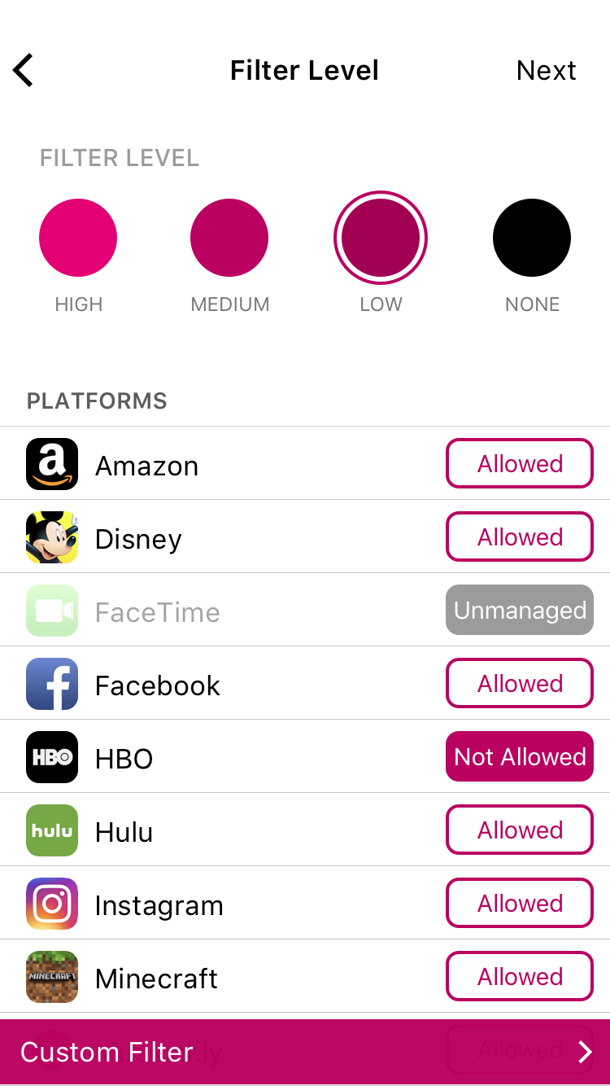
- Selecting “None” sets the Profile to Unmanaged, meaning FamilyMode won’t manage any online content for assigned devices.

See the “Tips for Parents” section for additional thoughts to consider in choosing a Filter Level.

Filter Settings
After you select a Filter Level, you can customize it by setting content to “Allowed,” “Not Allowed,” or “Unmanaged” by tapping the text-box across from the Platform or Category name. The “Allowed” setting means that content from this source is available and tracked by FamilyMode, whereas “Not Allowed” means that this content is restricted by the Filter. “Unmanaged” means that Internet traffic is allowed to freely come and go from this site, even if FamilyMode is set on Pause, BedTime, or OffTime.
Tapping “Custom Filter” (on the bottom of the screen) lets you create a Filter setting for an individual site. Just type in the name of the site and pick a Filter setting for it.

Categories
Entertainment
- Arts & Entertainment: Visual arts, literature, humor, film, arts venues, and more.
- Music: Audio streaming and downloading, artist sites, and more
- Online Games: Videogames and board game sites.
- Sports & Recreation: Sports media, professional teams, and recreation.
- Video: Video streaming and downloading.
School & Work
- Business: Employment, job postings, finance, and industry services.
- Education: Instructional content, teaching, educational institutions, and career prep.
- Science & Technology: Physical and social sciences as well as computers and artificial intelligence
Social
- Chat & Forums: Messaging services, online chat, bulletin boards, and forums.
- Social Media: Personal and professional networking communities
Lifestyle
- Blogs & Personal Sites: Blogging platforms and sites with personal content.
- Government & Politics: Government services, politics, lobbying, and military.
- Health: Personal health and fitness.
- Home & Family: Cooking, parenting, home-decorating, and more.
- Issues & Lifestyles: Social issues, philosophy, religion, and more.
- News: Journalism, commentary, and other reporting.
- Online Shopping: Ecommerce retailers and classified ads.
- Travel: Maps, travel, and tourism.
- Photo: Photography information and sharing.
Services
- App Stores & Downloads: Digital software distribution for apps, programs, and more.
- Email: Electronic mail providers.
- Search & Reference: Online search and information resources.
Adult
- Dating: Online dating and match-making.
- Explicit Content: Graphic and explicit adult content.
- Gambling: Betting sites, lotteries, casinos, racetracks and more.
- Mature: Adult-specific content (age 18+ or 21+).
- VPNs & Proxies: Internet privacy and network routing services.
Category descriptions are intended to describe the types of content that setting will attempt to filter. You may disagree with a description or find content that you believe should be covered by a category but isn’t. FamilyMode content filtering involves software that is constantly learning and improving.

Privacy and Safety
- “Ad Blocking” filters out many sources of online advertising.
- “Safe Search” filters sexually-explicit content from search results in Google and Bing.
- “YouTube Restricted” mode (provided by YouTube) blocks major categories of content, including Music.

3.9 BedTime
Make late-night surfing a thing of the past. A BedTime shuts off Internet access for every device assigned to a Profile through the night, so everybody in your family can get the sleep they need without distraction. You can even set a separate Weekend BedTime!
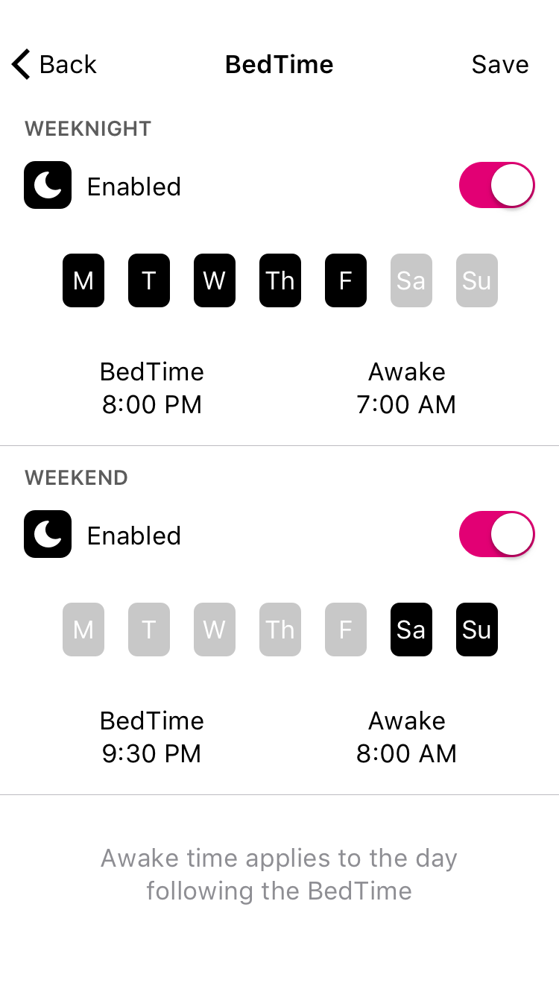
When setting BedTimes, keep in mind that the day of the week represents the night the BedTime begins, so a typical weekday schedule goes from Sunday to Thursday, with the weekend being Friday to Saturday.

To set a BedTime:
- Tap on a Profile from the home screen, then select “BedTimes” from the feature list.
- Turn BedTimes on by tapping the “Enable” switch in the top right.
- Set the BedTime by tapping on the days to toggle them on or off, and tap the “BedTime” and “Awake” times to set the clock.
- Tap “Add Weekend” to set an alternate BedTime for certain days of the week.
- Press “Save” to finish.

3.10 Time Limits
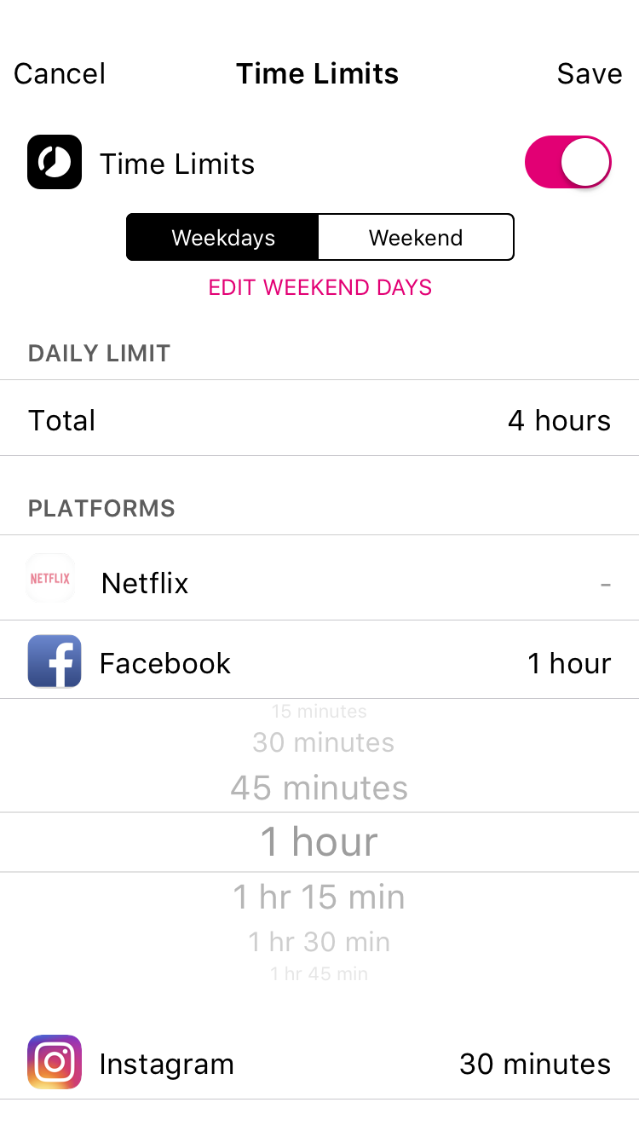
Limit online time for individual apps, sites, categories, and even total time with ease. Setting a Daily Time Limit ensures that your family members won’t get any more than this amount of online time for the day, across all types of content. Similarly, setting Category Time Limits means that even if there’s still time remaining on a specific Platform, family members won’t get more than a certain amount of Social Media, Online Games, or other content for the day.

To set a Time Limit:
- Tap on a Profile from the home screen, then select “Time Limits” from the feature list.
- Turn Time Limits on by tapping the “Enable” switch in the top right.
- Set an all-day cap by tapping “Daily Time Limit” at the top of the list.
- Tap the name of a Platform or Category to set an individual limit.
- Create an alternate schedule for certain days of the week by tapping “Add Weekend” near the top of the screen.

3.11 OffTime
Schedule offline moments in advance, so you can enjoy family time, get homework done, pay attention in class, and more. OffTimes are weekly recurring breaks from the Internet that you can create for your family members.

To set an OffTime:
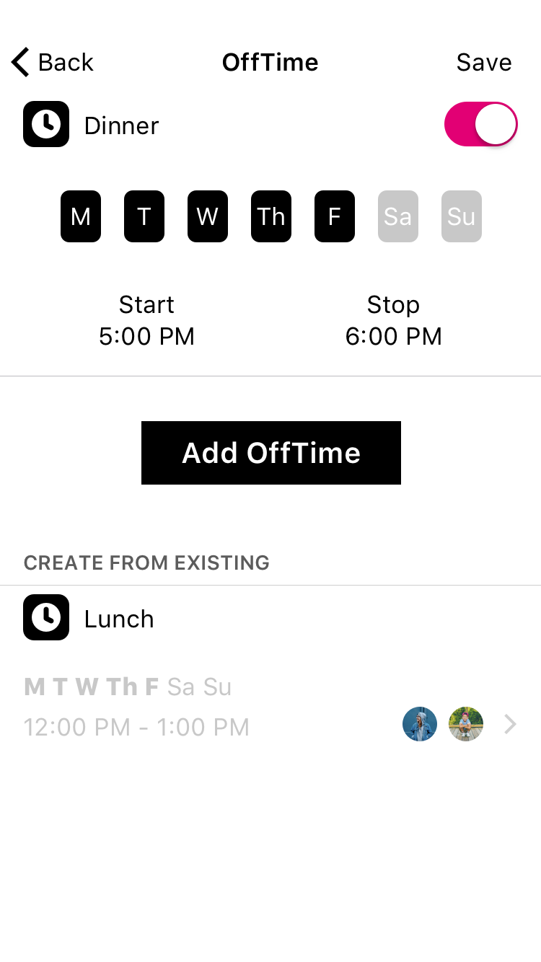
- Tap on a Profile from the home screen, then select “OffTime” from the feature list.
- Tap “Add OffTime,” or select from your existing OffTimes below.
- Set the OffTime by typing in a name for the OffTime, selecting which days you’d like to activate, and scroll through the the “Start” and “End” times to set the clock.
- Press “Done” to finish, then “Save” to keep all your changes for this Profile.

3.12 Rewards
Rewards are an easy way to send extra online time, and they expire at midnight, so whatever time you added goes back to normal on the following day. You can send as many Rewards as you’d like throughout the day.

To send a Reward:
- Tap on a Profile from the home screen, then tap the star in the top right corner, or select “Rewards” from the feature list.
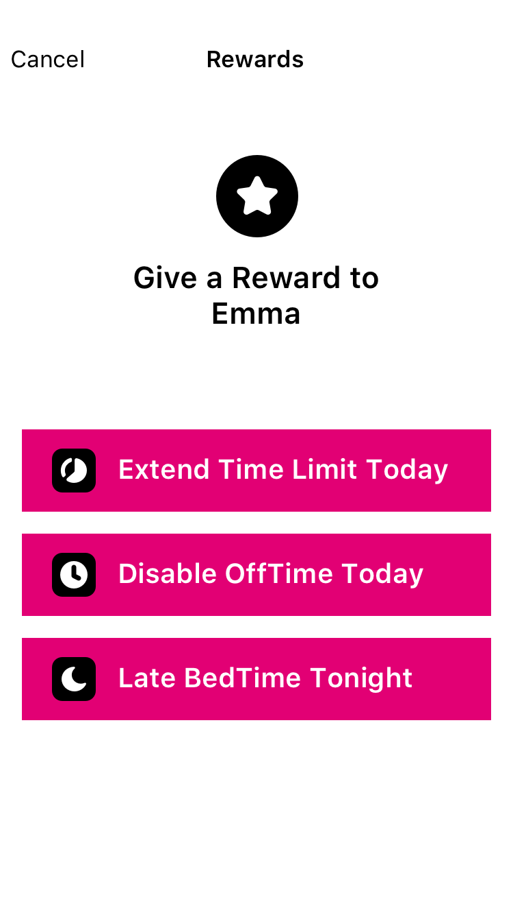
- Pick which type of Reward you’d like to send: Extend a Time Limit, Disable an OffTime, or give a Late BedTime.
- Set the Reward based on the existing settings, and press “Send” to finish.

Types of Rewards
- Pick “Extend Time Limit Today” to select any existing Time Limit and add additional time to it.
- Pick “Disable OffTime Today” to clear out an existing OffTime, just for the day.
- Pick “Late BedTime Tonight” to set a new start time for this evening’s BedTime.

3.13 Dashboard
The Dashboard is where your family can check their online time for the day, and find other helpful information.

Finding the Dashboard
If you’ve assigned a family member’s device to a Profile, they can use the Dashboard from the FamilyMode app or a web browser by visiting https://dashboard.t-mobilefamilymode.com and logging in with his/her T-Mobile ID.

What’s on the Dashboard?
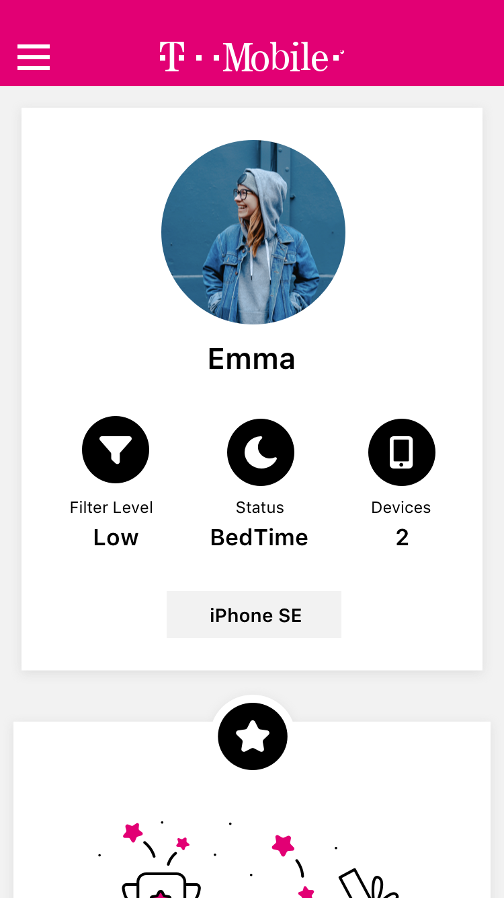
On the Dashboard, you’ll see information for the various FamilyMode features you’ve enabled for that family member. There’s also a general Profile card, where you can see the device name associated with this device in FamilyMode. Finding the device name can be helpful for identifying devices if you’re not sure which is which.

Dashboard Push Notifications
Push notifications let your family members know about changes to their Internet access throughout the day from FamilyMode. They’ll be notified about FamilyMode features like Pause, Time Limits, OffTimes, BedTimes, and more.

4. FamilyMode Home Base
LED:
- Solid light: on & paired
- Solid off: off
- Slowly blinking: on, but not paired
- Quickly blinking: resetting, low battery, or other internal error

Power button:
- To power on: press once
- To power off: hold for ten seconds, or until LED turns off

Introducing Home Base
A Home Base extends your mobile experience with FamilyMode to your entire Wi-Fi network, allowing you to manage every connected device in your home — laptops, smart TVs, game consoles, and everything else. You’ll still use the FamilyMode app, but you’ll have the added functionality of Home Base built right in.
Home Base works by pairing directly with your router and inspecting all the non-encrypted Internet traffic that comes through your home network, so you won’t need to install software or adjust any settings on your family devices to be able to manage them. Maintaining a strong and consistent connection between Home Base and your router will ensure a fast, reliable Internet connection in your home.

4.1 Setting Up a Home Base
- Make sure that your router is compatible with Home Base by visiting https://support.t-mobile.com/welcome.
- In the FamilyMode app, open the home screen menu — it’s located in the top left corner of the home screen — then select “Set Up Home Base.”
- Connect the device in your hand (running the FamilyMode app) to the same Wi-Fi network that you’re pairing with Home Base.
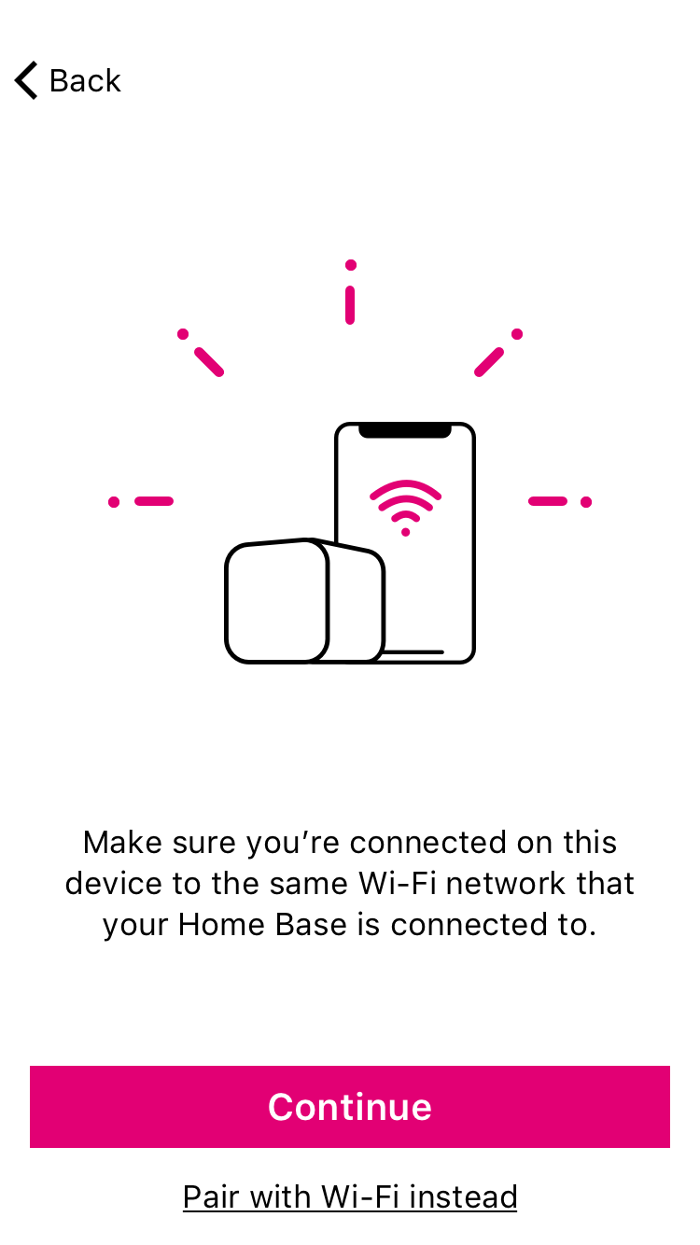
- Find your Wi-Fi router. It's the device that connects to your modem and provides Wi-Fi to your home. Make sure you’ve found your router, rather than a modem, network extender, or other piece of equipment, including a router that doesn’t belong to you. Set Home Base next to your router.
- Plug Home Base into a nearby wall outlet with the USB charger and make sure the light on the back has come on and is blinking slowly.
- Connect Home Base with your Wi-Fi router using the Ethernet cable.
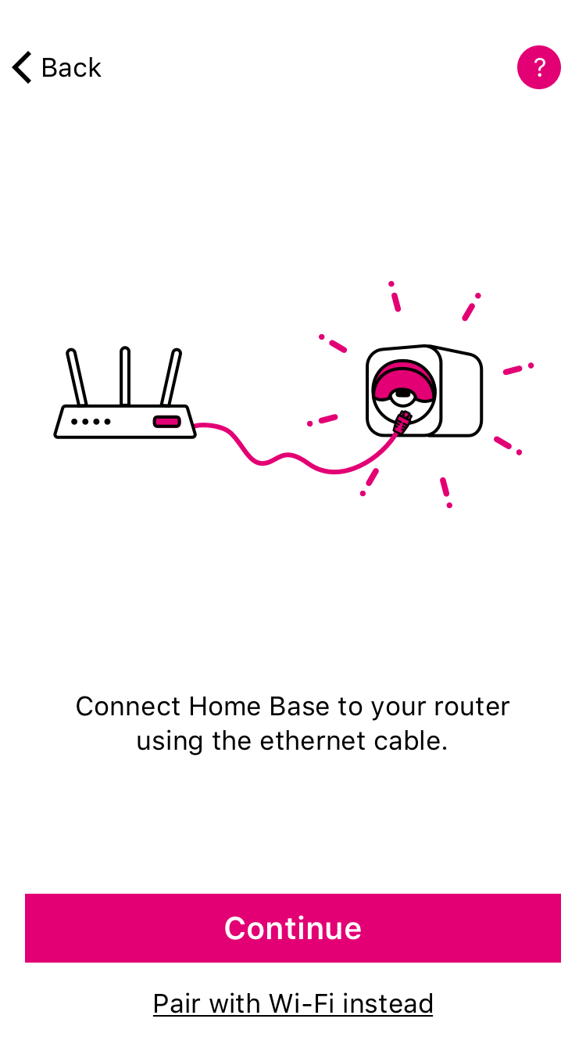
- Follow the steps in the FamilyMode app to pair Home Base to your network via Ethernet and Wi-Fi, then create your Home Profile by setting up a Filter and selecting all your family’s shared devices.
After setup, don’t forget to assign all new Wi-Fi devices that have been discovered by Home Base to your family members’ Profiles, so their existing settings will carry over to all their devices.
Important: your Home Base may discover Wi-Fi devices that do not belong to you or your family members. You may not use Home Base to manage or monitor Internet access for these devices without first informing the device owner and obtaining permission.

4.2 Wi-Fi Devices & Home Base
When you set up a Home Base, you’ll have access to a whole new group of connected devices to manage with FamilyMode: your family’s Wi-Fi devices.

Wi-Fi Devices Are Unmanaged By Default
Wi-Fi devices discovered by Home Base will be set to Unmanaged when they join, meaning that FamilyMode won’t interact with their Internet connection at any point. If you assign one to a Profile, it’ll be managed just like your mobile devices on your home network.

The Home Profile
The Home Profile is where all shared family devices live. You set a baseline Filter, plus any OffTimes or BedTimes to apply to all these devices. You can use this Home Profile any way you’d like by assigning the devices that make sense for your home.

Network Gear & Smart Home Devices
Leave all network gear and smart home devices Unmanaged. Any interference with Home Base may cause unexpected issues with these utilities and services. So, make sure that mesh Wi-Fi extenders and network fabric, as well as Internet of Things (“IoT”) devices like smart appliances, are never assigned to a Profile.

4.3 Troubleshooting Home Base Setup:
- If you don’t have a Home Base, visit a local T-Mobile store.
- If Home Base isn’t pairing with your network via Ethernet, make sure that the mobile device with the FamilyMode app (most likely your T-Mobile smartphone) is connected to the network created by your router. This way, FamilyMode can verify that the Home Base you’ve plugged in is associated with your FamilyMode account.
- If you don’t have a spare Ethernet port in your router, just skip Ethernet pairing by tapping “Pair with Wi-Fi Instead” during setup.
- If you skip Ethernet pairing, you’ll have to connect your phone to the Home Base hotspot. Follow the instructions in the app, and make sure that you stay connected to the Home Base hotspot, even though you won’t have an Internet connection on your phone for the moment.
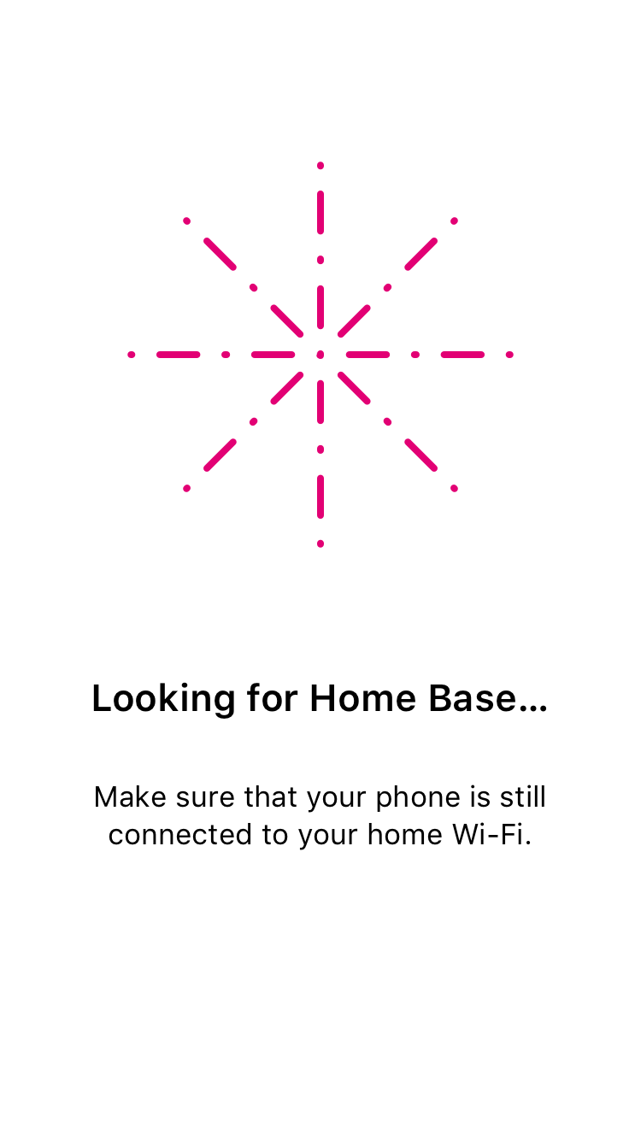
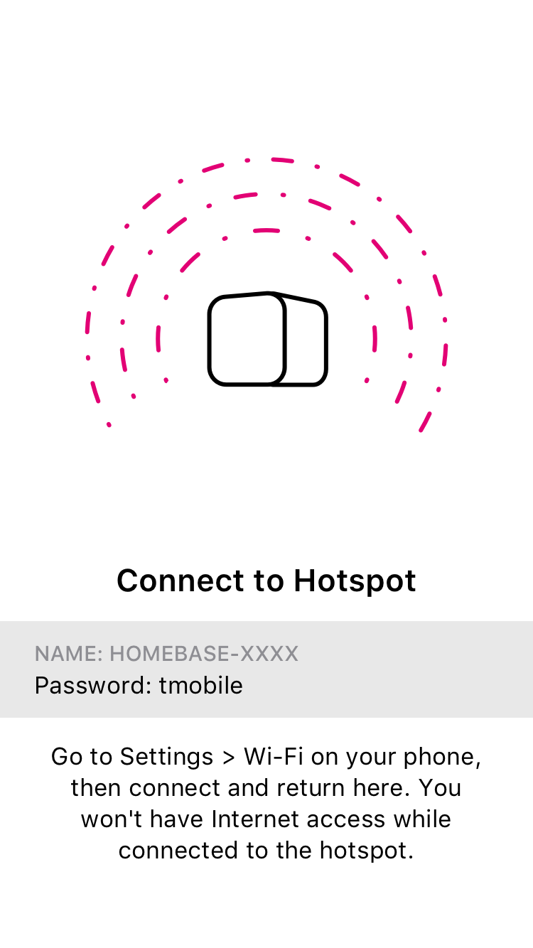
- If Home Base isn’t pairing with your network via Wi-Fi, make sure that you’ve connected to the Home Base hotspot (if the app required you to do so) before continuing, or that you’ve correctly entered your Wi-Fi password credentials into the FamilyMode app.
- If you paired Home Base over Ethernet but don’t use Wi-Fi, or you’re unable to pair wirelessly, just tap “Skip Wi-Fi Pairing” during setup.
- If your Home Base seems to be creating problems for your home network, try temporarily disabling it from the Settings screen (found by tapping the menu button in the top-left corner of the home screen, then “Settings,” then “Disable Home Base”). If the problem goes away after you’ve disabled Home Base, check to make sure that all networking equipment (like a mesh network extender or other network fabric) and smart home devices (like smart thermostats and lightbulbs) are set to Unmanaged.

5. Legal
This device complies with part 15 of the FCC Rules. Operation is subject to the following two conditions:
- This device may not cause harmful interference and
- This device must accept any interference received, including interference that may cause undesired operation

FCC INFORMATION
This equipment has been tested and found to comply with the limits for a Class B Digital Device, pursuant to part 15 of the FCC Rules. These limits are designed to provide reasonable protection against harmful interference in a residential installation.
This equipment generates, uses and can radiate radio frequency energy and, if not installed and used in accordance with the instruction, may cause harmful interference to radio communication.
However, there is no guarantee that interference will not occur in a particular installation. If this equipment does cause harmful interference to radio or television reception, which can be determined by turning the equipment off and on, the user is encouraged to try to correct the interference by one or more of the following measures:
- Reorient or relocate the receiving antenna.
- Increase the separation between the equipment and receiver.
- Connect the equipment into an outlet on a circuit different from that to which the receiver is connected.
- Consult the dealer or an experienced radio/TV technician for help.
This device complies with the radio frequency exposure limits in an uncontrolled environment as required by the FCC. To ensure that operation of the device does not exceed the FCC’s radio frequency exposure limits, a separation distance of at least 20 cm between the antenna of the device and any person should be maintained at all times during operation.

ADDITIONAL INFORMATION
This device will only operate with firmware versions that have been approved for use by T-Mobile and the device manufacturer. If unauthorized firmware is placed on the device it will not function.
Do not modify or change this equipment without written approval from T-Mobile. Unauthorized modification will void any applicable warranties and could void authority to use this equipment.
Use of some content or features may require qualifying service, or access to a Wi-Fi connection. See Terms and Conditions (including arbitration provision) at T-Mobile.com, for rate plan information, charges for features and services, and restrictions and details. Pause the Internet is a registered trademark of Circle, Inc. T-Mobile and the magenta color are registered trademarks of Deutsche Telekom AG. FamilyMode is a trademark of T-Mobile USA, Inc. © 2018 T-Mobile USA, Inc.

